**Software Requirement Specification for**

**“User Management & Attendance Tracker System”**

**Version 1.1**

**Prepared By Group 3**

|  |  |
| --- | --- |
| **Name** | **ID No.** |
| Hossain, Md. Shohan | 13-23317-1 |
| Chowdhury, Koushik | 13-23200-1 |

**Abstract**

*The aim of the project is to develop “User Management & Attendance Tracker System” that is able to deliver access to anyone authorized anytime, anyplace on any device. The system shares the advantage of both web application & desktop application, and removes the most disadvantages of both. At the end of the project, the system will be developed. Only requirements are an internet connection and a web browser.*

**Table of Content**

|  |  |
| --- | --- |
| ***ABSTRACT*** | *2* |
| ***TABLE OF CONTENT*** | *3* |
| *1.1 Project Goals* | *4* |
| *1.2 Project Purpose* | *4* |
| *1.3 Business Opportunity* | *4* |
| *1.4 Project Background* | *5* |
| *2. Project Scope* | *5* |
| *2.1 Project Outcome* | *5* |
| *2.2 Reality based Reasoning* | *5* |
| *2.3 Quality objective for the Project outcome* | *6* |
| *2.3.1 Reliability* | *6* |
| *2.3.2 Usability* | *6* |
| *3. Project Plan* | *6* |
| *4. Project Description* | *7* |
| *5. Project Organization & Stakeholder* | *7* |
| *5.1 Project Organization, Roles, Responsibility & Authority* | *7* |
| *5.2 Connecting to other projects* | *8* |
| *5.3 Reporting & Communication Principles* | *8* |
| *6. Project Strategy* | *9* |
| *6.1 Figure: Water Fall Model* | *10* |
| *7. Supporting Activities* | *10* |
| *8. Project Handover* | *10* |
| *8.1 Handling of Changed Requirement* | *11* |
| *9. Task Breakdown* | *11* |
| *References* | *12* |

**1.1 Project Goals:**

The rapid increase in population of the world, the number of expected students in universities and other educational institutions are increasing. These large amounts of students are getting difficult to manage by analog system. Providing quality education and assessing them fairly has become a challenge to be deal with. In order to make the situation easy, our program can be used by both the course instructors and students to save time and get access to official virtual management system. The time estimated for the submission of the project is just before the final term examinations.

**1.2 Project Purpose:**

The Purpose of this Documentation is to capture the description and requirements of “User Management & Attendance Tracker System” for any educational institution. One cannot implement a system without a proper document. In this document, Designer are supposed to provide a clear concept of the system which will help the programmer to implement the system appropriately. This is a functional description of those features required to address user management and attendance tracker requirements. The document gives the detailed description of the both functional and nonfunctional requirements proposed by the client. The document is developed after a number of consultations with the client and considering the complete requirement specifications of the given Project.

The System will be implemented for both Desktop and Web where one can usually manage their needs. More specifically to design and develop a system which will full fill the need of any educational institutions.

**1.3 Business opportunity:**

The amount of user is increasing day by day. In every system user management is vital element. Without a proper user management it is hard to manage all the end user to manage depending on their role.

There will be variety types of user. Every of them will not have the same access. So a good user management is always important. Our project is based on user management. Without this system it will not be easy to maintain the whole project. So business opportunity is always there for user management. The potential is high in software project.

**1.4 Project Background:**

The Student number of any education institution grows over time. The process of each record getting to be difficult as well as students of modern era are now tends to look for better system.

The purpose of creating such system is to improve an educational institution’s capability. The user of the system would be more capable of handling more functionality such as view their own registered account where they have more function which will help to connect themselves with educational system.

**2. Project Scope:**

The scope of this project is to design and develop a system for educational institution. The system will be implemented for both Desktop and Web where one can easily manage their role in the institution. They can easily handle their institution life with this system such as they can go to account and can view their necessary needs and status. The only requirement is good internet connection.

**2.1. Project Outcome:**

User management is a system which is meant to help the user to connect with his/her education institution. It provides login and sign up for the user. There are mainly three type of user. Admin, Student, faculty. Admin is a user who is the administrator of the whole system and who has ability to manage both student and faculty as well as the role of students and faculty are defined. Attendance Tracker is another system which is meant to keep the record of people who are present or absent.

**2.2 Reality Based Reasoning:**

The need of this project is to ensure that all the students, faculty and officials are being assessed in the virtual management system accordance to their individual role. Every person does not have the same role in a system. Like teachers have some individual role but students don’t need those. So this user management system will help to overcome these types of issue.

The other main aspect that makes this program so essential is that it would help to save a lot of time. The analog management system is time killing and frustrating. Other part of the project will help to replace register book of attendance. This will also save time and unnecessary work.

**2.3. Quality objective for the Project outcome:**

The quality of the software would be different from any other program of its kind. This uniqueness comes from its ability to handle user role and user role allocation. Now, some of the points can be highlighted to understand why the software is better.

**2.3.1 Reliability:**

The software would be very reliable .It’s operation would be functional .The unique intelligent way of allocation user role through the whole software system.

**2.3.2 Usability:**

This software would be very handy and very easy to use. Every user would login using their respected identification number, which would redirect them to individual access depending on their position. Example: A Faculty member would have the privilege to add or remove questions to the question list. Whereas, the students access in the software would be limited. They would only be able to select their individual departments and sit and for quizzes and submit according to their Individual Identification number.

**3. Project Delivery Plan:**

|  |  |
| --- | --- |
| ***User Management*** | ***Date:*** |
| 1.User Registration | 18/11/2015 |
| 2. User Role | 21/11/2015 |
| 3.User Profile | 28/11/2015 |
| 4.User Authorization | 30/11/2015 |

|  |  |
| --- | --- |
| ***Attendance Tracker*** | ***Date:*** |
| 1. Enter card | 03/12/2015 |
| 2. Verify | 07/12/2015 |
| 3. Record | 09/12/2015 |

**4. Project Description:**

The project is based on the goal to create software that would allow user to access the system depending on their roles. The program would allow the administrator open new account and define the role for new account. User then can access to his/her profile depending on their role by using admin generated id (student id) and password. Then the user will able to change his/her password which was generated by admin.

Student and teacher will able to change or add some information regarding their role. Specially teacher will able to view student accounts by their identification number. If administrator adds any new module or application then he will able to fixed role for using that module. The unique feature of this project is altering the user role. Here admin can alter his role to teacher and student as well. One user will able to customize their role and can gain the multi user role access at the same time.

Our next part of the project is about attendance tracker. Where system will take unique id scanning as present and second scanning within that day will confirm the leave.

**5. Project Organization and Stakeholder:**

Education management system has a growing market now a days. Now a days most of the educational Institute uses this kind of software to maintain their official and educational activities properties. In this field this software will a new horizon.

**5.1 Project Organization, Roles, Responsibility and Authority**

Before proceeding further into the project, it is necessary to note down the client requirement completely. The requirement was a software capable of user authentication role deliver and also check attendant of the students. The user role allocation application will able to define every authorized user to define their role and access.

**5.2 Connecting to Other Projects:**

The Whole project is divided into 8 parts. Our part is named “User Management & Attendance Tracker” where we will work with user like Faculty/Teacher, Students & Admin. Admin is someone who can administrate the whole system. Our part is the main part. We collect the necessary information from other groups which will help us to implement our system more appropriately. Collecting information from other group is necessary. With help of these information, we can design our user needs more efficiency or we can implemented system with more functionality.

## 5.3 Reporting and Communication principle:

The purpose of communications management is to share the right information, at the right time, with the right people, and in the right format. Good communications management means expending effort on communicating information which contributes to project success or where lack of information can lead to failure. We will do this by identifying the correct target audience for different categories of communications.

Both formal and informal methods will be used to share information. Formal communication methods are those that follow well defined procedures, while informal communications are more casual. Weekly status reports that contain information about progress and issues are a well-known formal communication tool. Other examples include decision requests, and risk logs. Voice mail messages and conversations over lunch or coffee are examples of informal communications which we will document when pertinent.

### Implementation

Communications Management is implemented through three essential processes, all of which will be a joint responsibility of our Project Manager and your Project Manager. The processes are:

* **Identification**: process of identifying information to be shared, when it should be distributed, who should receive it, and how it should be prepared;
* **Reporting**: process of collecting and preparing the information; and,
* **Distribution**: process of disseminating the information, and for formal communications, storing the information in the project archive.

**6. Project Strategy:**

The strategy that is basically being followed is the WATER FALL MODEL, which states that the phases are organized in a linear order. First of all the feasibility study is done. Once that part is over the requirement analysis and project planning begins. The design starts after the requirement analysis is complete and the coding begins after the design is complete. Once the programming is completed, the testing is done. In this model the sequence of activities performed in a software development project are: -

* Requirement Analysis
* Project Planning
* System design
* Detail design
* Coding
* Unit testing
* System integration & testing

Here the linear ordering of these activities is critical. End of the phase and the output of one phase is the input of other phase. The output of each phase is to be consistent with the overall requirement of the system. Some of the qualities of spiral model are also incorporated like after the people concerned with the project review completion of each of the phase the work done. WATER FALL MODEL was being chosen because all requirements were known beforehand and the objective of our software development is the computerization/automation of an already existing manual working system.

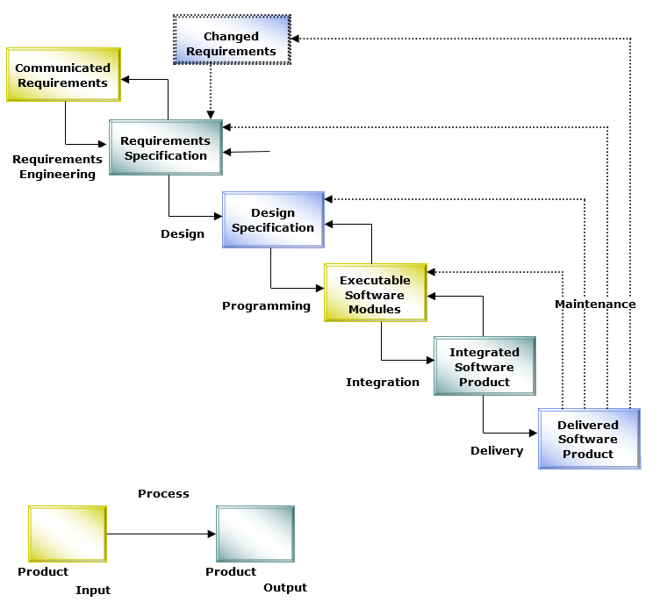

*6.1 Fig: Water Fall Model*

## 7. Supporting Activities:

There will be two types of supporting activities. One is user will able to report any kind of bug or issues regarding to the management system. Other one is they will able to suggest new feature to supporting department for adding with existing project. A group of supporting expert will slot the degree of importance of report and feature in the project.

**8. Project Handover:**

The handover of a project to the client at the end of construction is a very important stage of the project. The document of the project would be handed over to the client personally with the detail of the project. This also provides proof of the clients that a well organize, efficient and effective transfer of information from project works to the client. Projects will require a dedicated project meeting to discuss the project handover process and to agree on requirements and outcomes. The project manager will arrange this meeting with all project group members. We also declare that we would be responsible for any queries and would gladly provide services in future.

### 8.1 Handling of Changed Requirements:

If any changes needed at the project development phase then it will be first handled by implementing in use case diagram. By this we will able to determine the benefit of this new feature. If it seems handy then we will implement as beta version. After testing all possible way we will release it for end user.

**9. Task Breakdown**:

|  |  |
| --- | --- |
| **Task** | **Done by** |
| Project Goals | Hossain, Md. Shohan |
| Project Purpose | Chowdhury, Koushik |
| Project Background | Chowdhury, Koushik |
| Reality Based Reasoning | Hossain, Md. Shohan |
| Project Description | Hossain, Md. Shohan |
| Project Outcome | Chowdhury, Koushik |
| Quality objective for the Project outcome | Hossain, Md. Shohan |
| Organizational Requirement | Hossain, Md. Shohan |
| Project performance Quality Objectives | Hossain, Md. Shohan |
| Project Strategy | Chowdhury, Koushik |
| Manual University System | Chowdhury, Koushik |
| Security | Chowdhury, Koushik |
| Project Handover | Hossain, Md. Shohan |
| Task Breakdown | Chowdhury, Koushik |
| Project Delivery Plan | Chowdhury, Koushik |
| References | Both |

**References:**

1. Template_Project_Spec.doc. Supplied by Syed Ishteaque Ahmed Sir.

2. <http://www.wjeis.org/FileUpload/ds217232/File/26.yorulmaz.pdf>

3. <https://www.uploady.com/#!/download/9VgsZFVyXRL/wjQHvWiismv~kUi1>